UML STATE DIAGRAM
also known as a state machine diagram

Model the behavior and/or the sequence of events an object goes through

PARTS

Filled Circle – representing the initial statements

Hollow circle with a smaller filled circle – indicates final state

Rounded rectangle showing a state, with name of the state. Activities done in the state can be shown with a horizontal line

Arrow – showing transitions

others

guard expression
join/fork

Ex. from internet
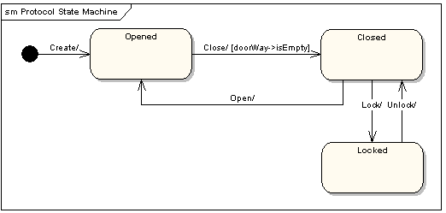

SOURCES:

https://en.wikipedia.org/wiki/State_diagram_(UML)

